IDEA LAB PROJECT PROPOSAL
Agentic AI: Autonomous Insurance Claims Triage & Fraud Assistant
Domain: Banking & Insurance (BFSI) | Focus Areas: Machine Learning, Deep Learning, Agentic AI

1. Abstract
Insurance claims fraud costs the global industry tens of billions of dollars annually, and manual claim review is slow, inconsistent, and difficult to scale as claim volumes grow. This project proposes an Agentic AI system that goes beyond a single predictive model: it combines a Machine Learning / Deep Learning fraud-scoring engine with an autonomous reasoning agent that extracts claim details, retrieves similar historical claims, applies policy checks, and produces a structured, explainable recommendation — approve, flag for investigation, or request more information — for a human adjuster to review. The project mirrors the direction major banks and insurers are already moving in: pairing predictive models with agentic workflows to reduce manual review time while keeping a human firmly in the loop for final decisions.

2. Problem Statement
Traditional fraud-detection systems in insurance rely on either static rule engines or standalone ML classifiers that output only a probability score, leaving the adjuster to manually gather supporting context (similar past claims, policy history, documentation gaps) before making a decision. This creates two problems:
- High manual workload — adjusters spend significant time on context-gathering rather than judgment, slowing down genuine claims and delaying fraud investigation.
- Low explainability — a bare fraud-probability score gives no reasoning, making it hard for adjusters (and regulators) to trust or audit the decision.
The problem to solve: design and build an agentic AI system that autonomously performs the multi-step reasoning a human adjuster would otherwise do manually — extract, validate, score, compare, and recommend — while producing a transparent, auditable rationale for every decision, with a human adjuster retaining final authority to approve or override.

3. Objectives
- Build an ML/DL model that predicts the probability that a given insurance claim is fraudulent.
- Design an autonomous agent (LLM-based orchestrator) that plans and executes a multi-step triage workflow using tools rather than a single fixed inference call.
- Implement a similar-claims retrieval mechanism so the agent can compare a new claim against historical patterns.
- Generate a structured, human-readable decision with rationale for each claim (approve / flag / request more info).
- Build a lightweight human-in-the-loop dashboard so an adjuster can review, override, and provide feedback.
- Close the feedback loop — adjuster decisions can be used to retrain and improve the underlying ML/DL model over time.

4. Deliverables
- Cleaned & documented dataset with exploratory data analysis (EDA) report.
- Trained and evaluated ML/DL fraud-scoring model (with accuracy, precision, recall, F1, and AUC-ROC metrics).
- Functional agentic pipeline (orchestrator + tools: fraud scoring, similar-claims retrieval, policy/history check).
- Working demo dashboard for claim submission, agent decision output, and adjuster review/override.
- Final project report covering problem, methodology, architecture, results, and future scope.
- Presentation deck / demo video for Idea Lab evaluation.

5. Scope

In Scope
- Structured claims data (policy, incident, claim-amount fields) as the primary input; optional free-text claim description handling.
- A single insurance line (auto/vehicle insurance) as the working domain, to keep the dataset and rules tractable for a student project timeline.
- An agent built on an open-source or free-tier LLM API with 2-3 callable tools (fraud model, retrieval, basic policy checks).
- A simple, functional (not production-grade) review dashboard.

Out of Scope
- Real-time integration with live insurer core systems or actual customer data.
- Full regulatory/compliance certification (explainability is addressed at a project level, not an audited production level).
- Multi-line insurance support (health, life, property) — could be listed as future work.
- Image-based damage assessment from claim photos (optional stretch goal only, not core scope).

6. System Architecture & Flow of Phases
The system is organized into six phases, moving from raw claim intake through to a human-approved decision, with a feedback loop back into the ML model:
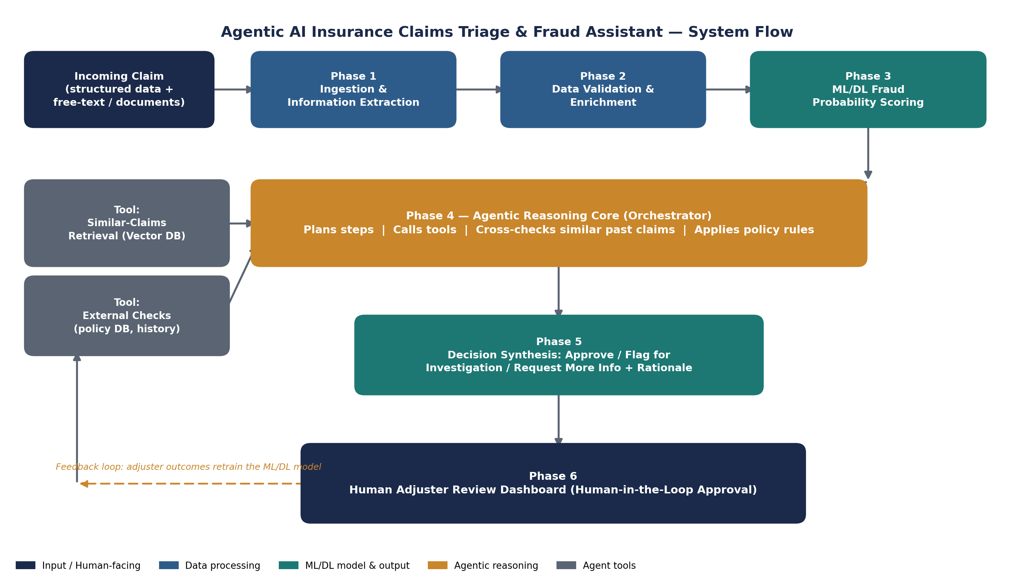
Phase-by-phase description:
- Phase 1 — Ingestion & Information Extraction: Claim intake (structured fields + optional free text) is parsed and normalized into a common schema.
- Phase 2 — Data Validation & Enrichment: Missing-field checks, basic consistency checks (e.g., incident date vs. policy start date), and feature engineering.
- Phase 3 — ML/DL Fraud Probability Scoring: The trained model outputs a fraud-likelihood score for the claim.
- Phase 4 — Agentic Reasoning Core: The orchestrator agent plans next steps, calling tools such as similar-claims retrieval and policy/history checks as needed, rather than following one fixed script.
- Phase 5 — Decision Synthesis: The agent combines the fraud score and retrieved context into a structured recommendation with a written rationale.
- Phase 6 — Human Adjuster Review: A human reviews the recommendation and rationale, approves or overrides it; this outcome feeds back to improve the ML model over time.

7. Suggested Team Structure (4 Members)
Role | Responsibility | Suggested Skills
Data & ML Lead | Dataset prep, EDA, ML/DL fraud model training & tuning | Python, pandas, scikit-learn, XGBoost
Agentic AI Lead | Design & build the agent orchestrator and tool integrations | LangChain/LangGraph, prompt design, APIs
Backend/Integration Lead | Pipeline wiring, similar-claims retrieval (vector DB), APIs | Python/FastAPI, vector DBs (FAISS/Chroma)
UI & Documentation Lead | Adjuster dashboard, testing, report & presentation | Streamlit/Flask, technical writing

8. Project Plan / Phases Timeline
Phase | Focus | Key Activities | Duration
1. Foundation & Data | Domain study + dataset prep | Study insurance claims lifecycle; download & clean Kaggle dataset; EDA; define fraud labels & features | Week 1-2
2. ML/DL Model | Fraud probability scoring | Train & tune baseline (Logistic Regression, Random Forest) and advanced (XGBoost / Neural Net) models; handle class imbalance; evaluate with Precision/Recall/AUC | Week 3-4
3. Agentic Layer | Orchestrator + tools | Build LLM agent using LangChain/LangGraph; wrap ML model, similar-claims retrieval, and policy-check as callable tools | Week 5-6
4. Integration | End-to-end pipeline | Connect ingestion → validation → ML scoring → agent reasoning → decision output into one pipeline | Week 6-7
5. Interface & Review | Human-in-the-loop UI | Build a simple dashboard (Streamlit/Flask) for adjusters to view claim, fraud score, agent rationale, and approve/override | Week 7-8
6. Testing & Documentation | Validation + reporting | Test on held-out claims; measure accuracy and false-positive rate; prepare final report, demo, and presentation | Week 8-9

9. Suggested Technology Stack
- Languages/Core: Python
- ML/DL: scikit-learn, XGBoost, TensorFlow/PyTorch (for neural network variant)
- Agentic Framework: LangChain / LangGraph, or CrewAI
- Retrieval: FAISS or ChromaDB for similar-claims vector search
- Interface: Streamlit or Flask for the adjuster review dashboard
- LLM Access: OpenAI API, Anthropic API, or an open-source model, depending on availability/budget

10. Dataset Details
Two Kaggle datasets are recommended — the first as the primary training set for the ML/DL fraud model, the second as an alternate or supplementary source (e.g., to enrich the agent's similar-claims knowledge base).

10.1 Primary Dataset — Vehicle Claim Fraud Detection
Attribute | Details
Dataset name | Vehicle Claim Fraud Detection
Records / Fields | ~15,420 rows, 33 columns (8 continuous, 24 categorical)
Target label | FraudFound_P (0 = legitimate, 1 = fraudulent)
Key fields | Policy details, vehicle details, accident details, claim amount, policyholder demographics, days between incident and claim
Best for | Phase 2 & 3 — training the ML/DL fraud-probability model

10.2 Supplementary Dataset — Auto Insurance Claims Data
Attribute | Details
Dataset name | Auto Insurance Claims Data
Records / Fields | ~1,000 rows; policy, incident, and claim-amount fields plus a fraud-reported flag
Target label | fraud_reported (Y/N)
Key fields | Customer tenure, policy premium, incident type & severity, claim amounts (injury/property/vehicle), witnesses, police report availability
Best for | Alternate/supplementary dataset, or for the agent's similar-claims retrieval knowledge base

11. Dataset Links
- Vehicle Claim Fraud Detection (primary): https://www.kaggle.com/datasets/shivamb/vehicle-claim-fraud-detection
- Auto Insurance Claims Data (supplementary): https://www.kaggle.com/datasets/buntyshah/auto-insurance-claims-data
- Car Insurance Claim Prediction (optional alternate): https://www.kaggle.com/datasets/ifteshanajnin/carinsuranceclaimprediction-classification

12. Industry Reference
This project direction reflects real industry practice: JPMorgan Chase runs 450+ AI use cases in production across fraud detection and risk mitigation, and its 2026 roadmap explicitly includes exploring agentic systems in payments; JPMorgan, Citi, and Wells Fargo are similarly using ML for anti-money-laundering and anomaly detection. Global IT/consulting firms such as TCS, Infosys, Wipro, Cognizant, Accenture, Capgemini, and HCLTech build comparable fraud and claims-automation systems for banking and insurance clients. Framing the project this way gives the team a credible, industry-grounded justification for the Idea Lab evaluation.

13. Expected Outcomes / Success Criteria
- ML/DL model achieves reasonable fraud-detection performance (target: Recall and Precision both meaningfully above the naive baseline, given class imbalance).
- Agent correctly retrieves relevant similar claims and produces a coherent, policy-consistent rationale for at least the majority of test claims.
- End-to-end pipeline runs on a sample of held-out claims without manual intervention, producing a reviewable recommendation for each.
- Dashboard allows an adjuster to view claim details, score, rationale, and record an approve/override decision.

14. Future Scope
- Extend to other insurance lines: health, life, or property claims.
- Add image/document analysis for claim photo or repair-estimate verification.
- Integrate multi-agent collaboration (e.g., a separate compliance-check agent working alongside the fraud-triage agent).
- Deploy on cloud infrastructure with a proper API layer for realistic system testing.

